# CS 255 System Design Document

## UML Diagrams

### UML Use Case Diagram

### UML Activity Diagrams

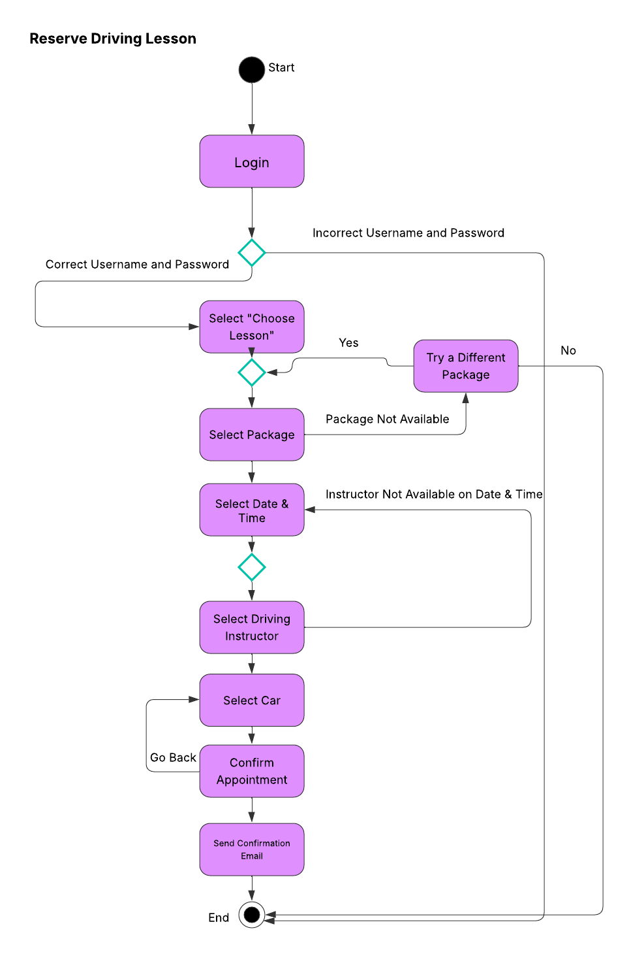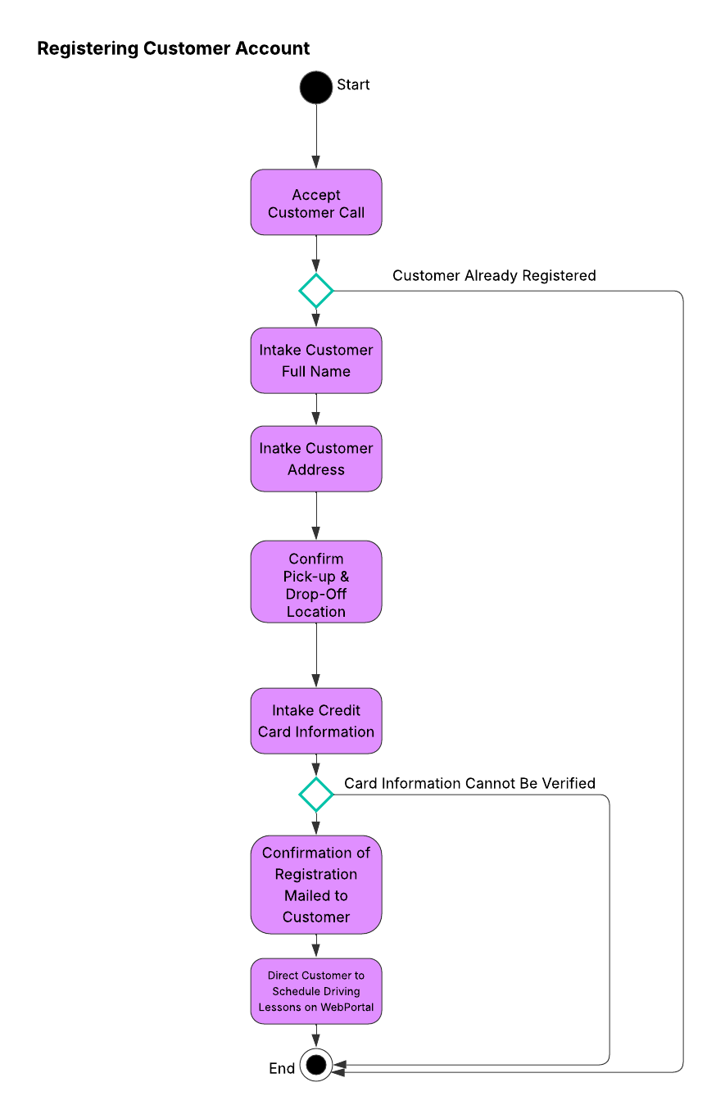

### UML Sequence Diagram

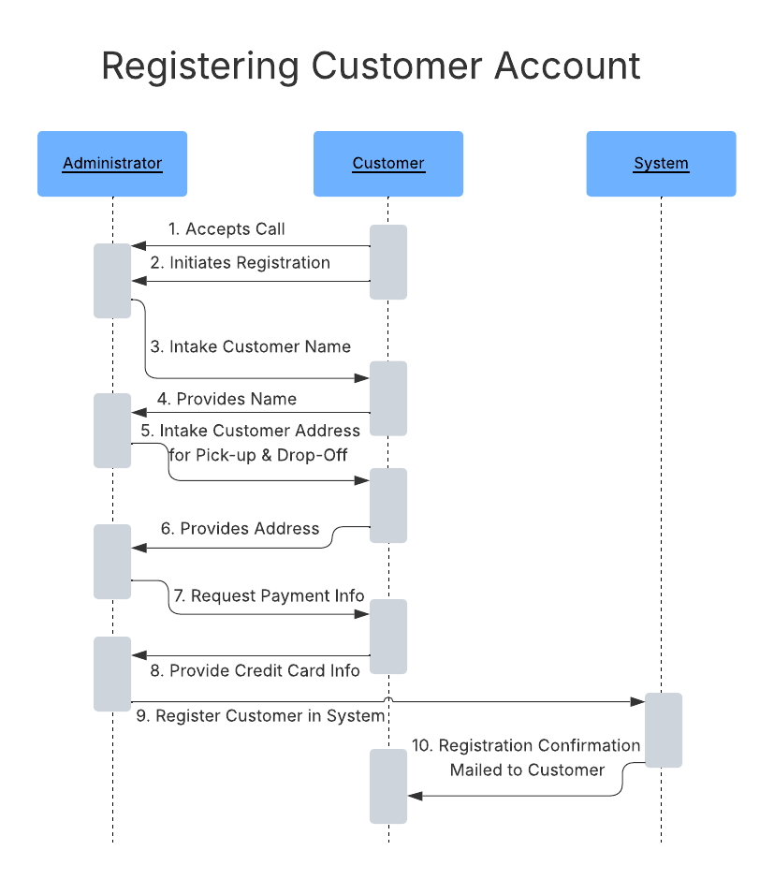

### UML Class Diagram

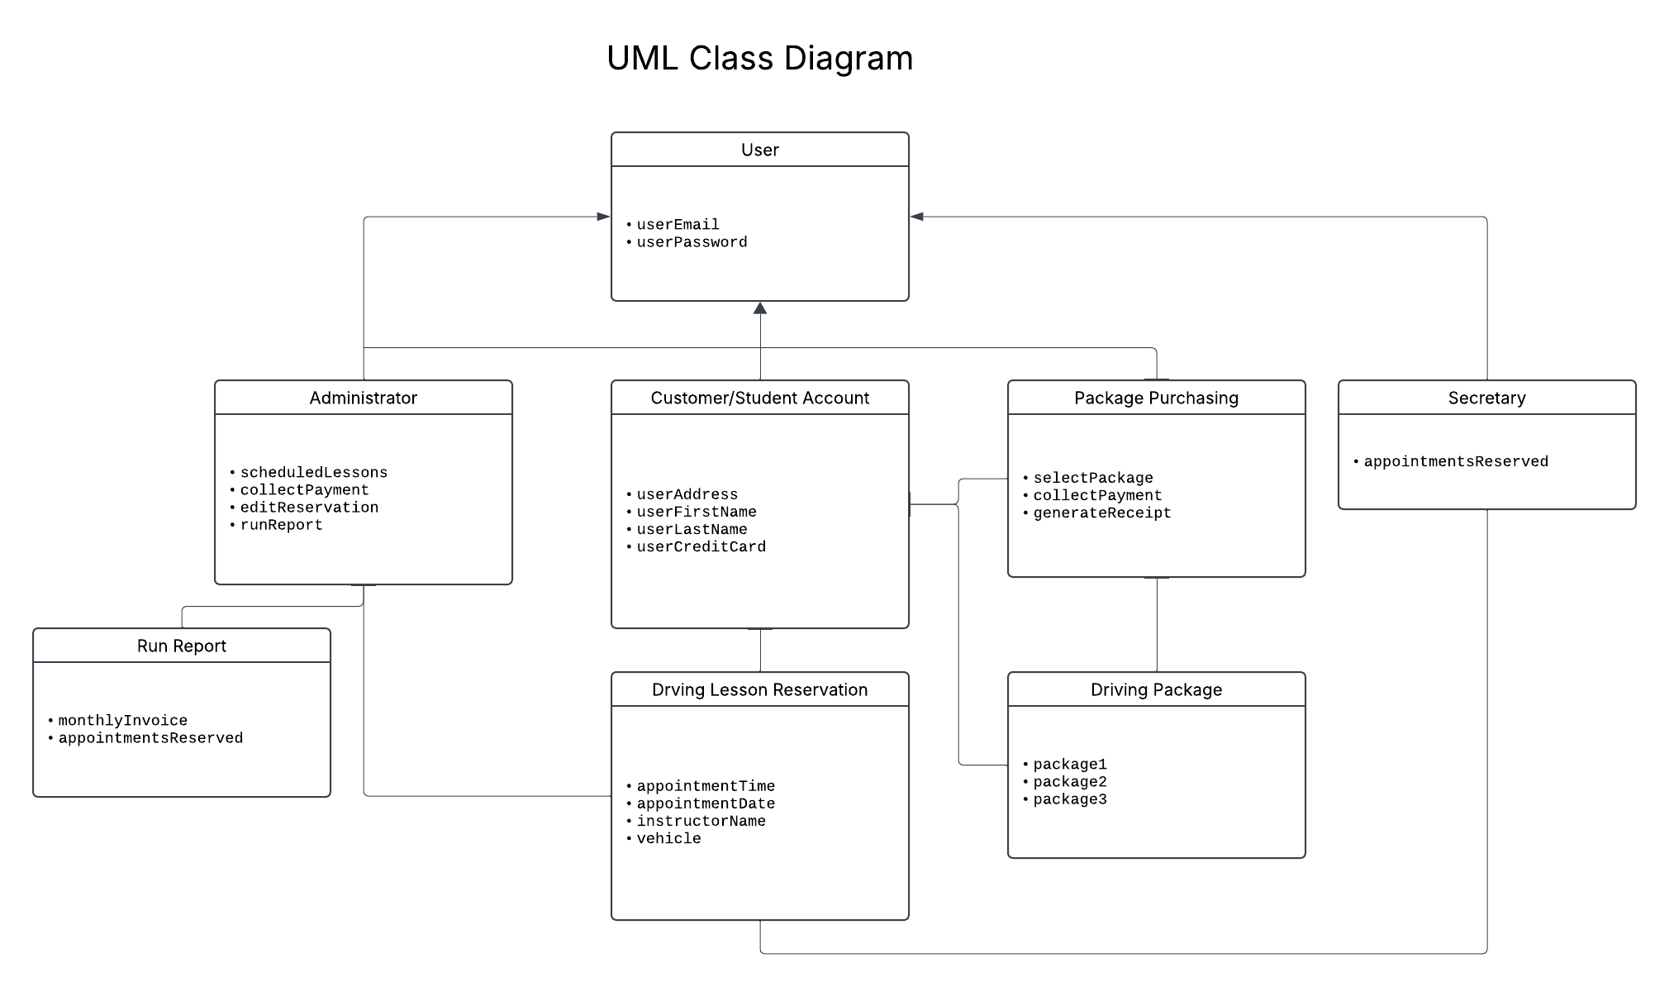

## Technical Requirements

* Hardware Requirements:
  + Web servers capable of hosting the application and managing user requests.
  + Database servers for storing user data, appointment schedules, and training materials.
  + Backup servers to ensure data redundancy and recovery in case of failure.
  + Client devices (computers, tablets, and smartphones) for users to access the system.
* Software Requirements:
  + A web application framework (e.g., Django, Ruby on Rails, or ASP.NET) for building the user interface and handling business logic.
  + A relational database management system (e.g., MySQL, PostgreSQL, or Microsoft SQL Server) for data storage.
  + A cloud service provider (e.g., AWS, Azure, or Google Cloud) for hosting the application and managing backups and security.
  + Security software for implementing encryption, user authentication, and access control.
* Tools:
  + Development tools (e.g., Visual Studio, Eclipse, or IntelliJ IDEA) for coding and debugging the application.
  + Version control systems (e.g., Git) for managing code changes and collaboration among developers.
  + Project management tools (e.g., Jira or Trello) for tracking progress and managing tasks.
  + User interface design tools (e.g., Figma or Adobe XD) for creating and prototyping the system's interface.
* Infrastructure:
  + A reliable internet connection to ensure users can access the system without interruptions.
  + A content delivery network (CDN) to improve the performance and speed of the web application.
  + Compliance with data protection regulations (e.g., GDPR or CCPA) to ensure user data is handled securely and responsibly.
  + Integration capabilities with the DMV's systems for real-time updates on rules, policies, and practice tests.